Patient-Survival-Prediction
Introduction
Project Background
In healthcare, predicting the risk of patient death during hospitalisation is critical to improving the quality of healthcare services and patient safety.With the digitisation of healthcare data and the development of machine learning technologies, it has become possible to use big data for patient risk prediction.By analysing data such as various physiological indicators, medical history, laboratory test results and other data of a patient at the time of admission, a prediction model can be built to assess the risk of death of a patient during hospitalisation.
Project Significance
1. Improvement of medical service quality: By predicting the risk of death of patients during hospitalisation, doctors can take preventive measures in advance and optimise treatment plans, thus improving the quality of medical services.
2. Resource optimisation: hospitals can rationally allocate medical resources, such as ICU beds and medical equipment, based on the prediction results to ensure effective use of resources.
3. Patient safety: Early identification of high-risk patients allows for timely intervention to reduce medical errors and improve patient safety.

Project Objective:
Identify Key Features and Risk Factors：Determine the critical physiological indicators and medical history factors that are strongly associated with the risk of inhospital mortality. This involves analyzing a comprehensive dataset of patient information to pinpoint which factors are most predictive of adverse outcomes.
Develop a Predictive Machine Learning Model：Construct a machine learning model that can accurately predict the probability of a patient dying during their hospital stay based on data available at admission. This model will be trained on a diverse dataset encompassing various patient demographics, medical histories, and physiological measurements.
Evaluate Model Performance：Assess the developed model's accuracy, sensitivity, specificity, and scalability using rigorous validation techniques. This evaluation will ensure the model's reliability and effectiveness in realworld clinical settings.
Create a UserFriendly Interface：Design an intuitive interface that allows healthcare professionals to easily input patient data and receive predictions. This interface will facilitate the integration of the predictive model into routine clinical workflows, making it accessible to a broad range of medical staff.
Propose EvidenceBased Guidelines：Establish guidelines for incorporating machine learning tools into clinical practice based on empirical evidence and model performance. These guidelines will assist healthcare institutions in effectively adopting and utilizing predictive analytics to improve patient care and operational efficiency.
Enhance Healthcare Service Quality：Enable early identification of highrisk patients, allowing for timely interventions and optimized treatment plans. This proactive approach aims to reduce mortality rates and improve overall patient outcomes.
Support Clinical DecisionMaking：Provide healthcare providers with datadriven insights to inform their decisions, reducing the likelihood of medical errors and enhancing patient safety. The model's predictions will serve as a valuable reference in complex clinical scenarios.
Dataset Description
Detailed description of the source and presentation of the dataset
Patient Survival Prediction, a dataset derived from Kaggle, uploaded and maintained by user Mitisha Agarwal, titled "Patient Survival Prediction".The dataset is updated on a weekly basis to provide the latest patient data to support research and model development.The dataset is licensed to the original authors and can be accessed at the following link: https://www.kaggle.com/datasets/mitishaagarwal/patient.
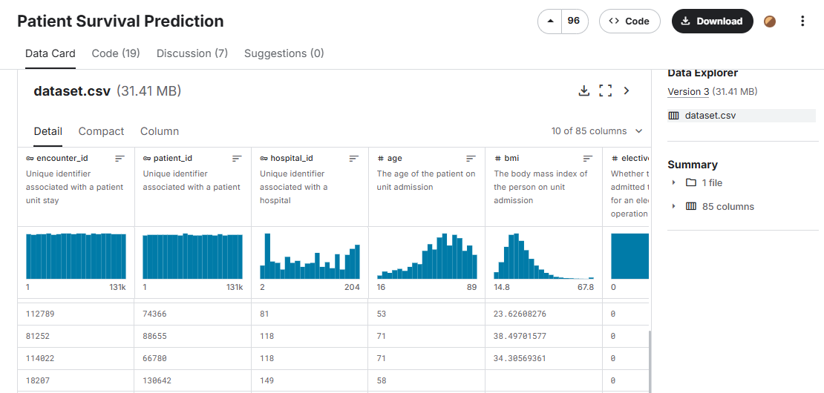
Structure and content of the dataset
The dataset contains multiple fields covering the patient's basic information, physiological indicators, medical history, diagnostic information, and monitoring data during hospitalisation.Among them, the basic information includes the patient's unique identifier, age, gender, race, etc.; the physiological indicators cover the patient's body mass index, height, temperature, heart rate, blood pressure, etc.; the medical history section records whether the patient has any chronic diseases such as AIDS, cirrhosis of the liver, diabetes mellitus, etc.; and the diagnostic information contains APACHE II and III diagnostic codes, as well as the patient's score of the Glasgow Coma Scale at the time of hospital admission.In addition, the dataset recorded various monitoring data of the patients during their stay in the ICU, such as diastolic blood pressure, systolic blood pressure, mean arterial pressure, respiratory rate, and peripheral oxygen saturation.These data provide a rich information base for the development and validation of models to predict the risk of death in hospitalised patients.

Model construction and evaluation
EDA
Missing value checking
There are some missing values in the dataset, such as 9585 missing values each for d1_potassium_max and d1_potassium_min, and 9084 missing values each for h1_mbp_noninvasive_max and h1_mbp_noninvasive_min.For these missing values, consider filling in using the mean, median, or plurality
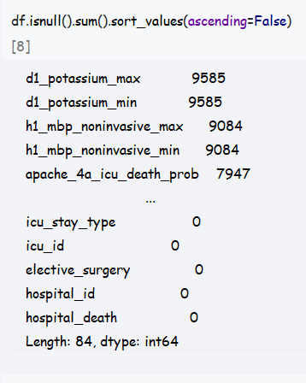
Feature analysis
Numeric features: 71 numeric features including encounter_id, patient_id, hospital_id, age, bmi, and so on.Statistical descriptions revealed that the age range of patients was between 16 and 89 years old, with a mean age of about 62 years; the mean value of BMI was about 29.19, with a standard deviation of 8.28; and the mean value of the hospital death label, hospital_death, was 0.086, suggesting that about 8.6% of the patients died during hospitalisation.
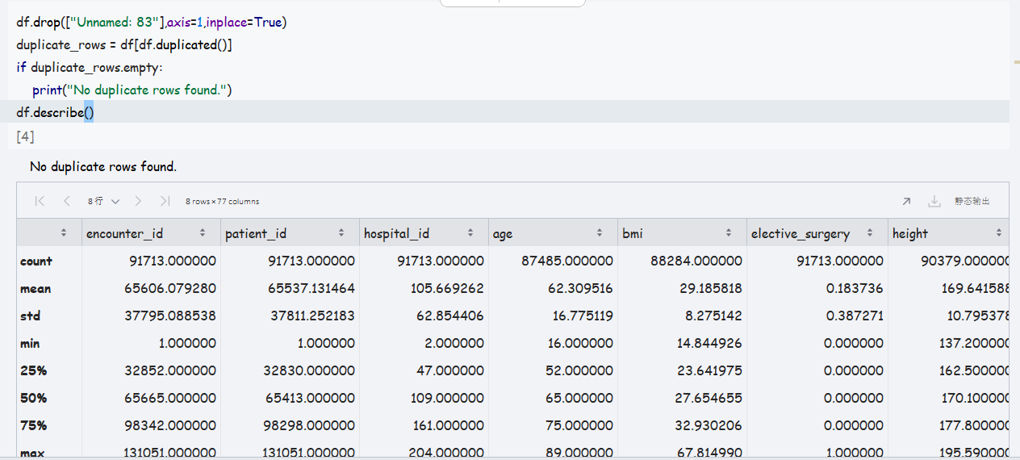
Sub-type features: seven sub-type features including ethnicity, gender, icu_admit_source, etc..For example, ethnicity is mainly classified into categories such as "Caucasian" and "African American"; gender is classified into "M" (male) and "F" (female).gender is divided into "M" (male) and "F" (female).And we explored the data distribution of the categorised features. Taking apache_2_bodysystem feature as an example, we performed the following visual analysis.
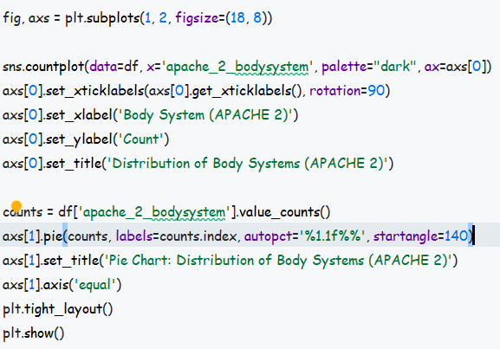
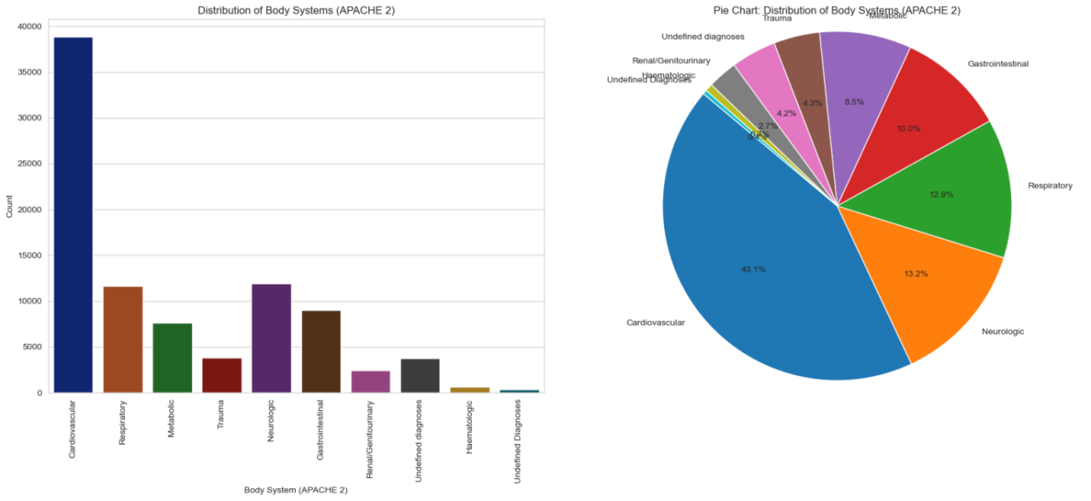
Correlation analysis of numerical type variables
The correlation analysis of the numerical type features shows that some of the features are correlated with the target variable hospital_death.For example, features such as apache_4a_hospital_death_prob and apache_4a_icu_death_prob have a high positive correlation with hospital_death, suggesting that these features may have an important impact on predicting the risk of patient death.
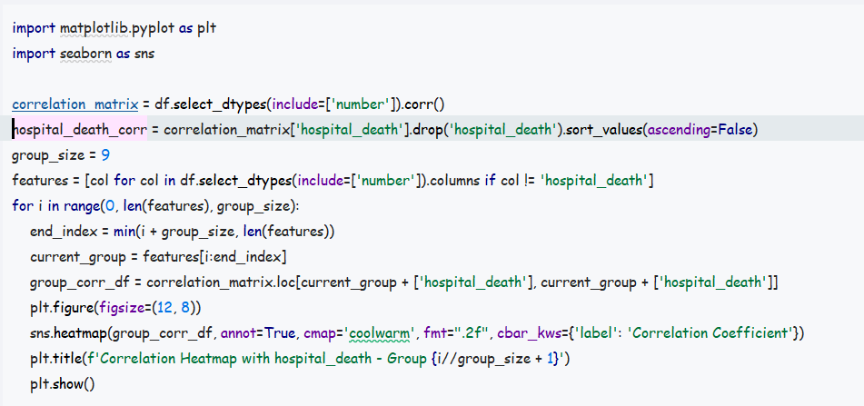
There are 80 features in total and below is a heat map of some of the features in relation to hospital_death.
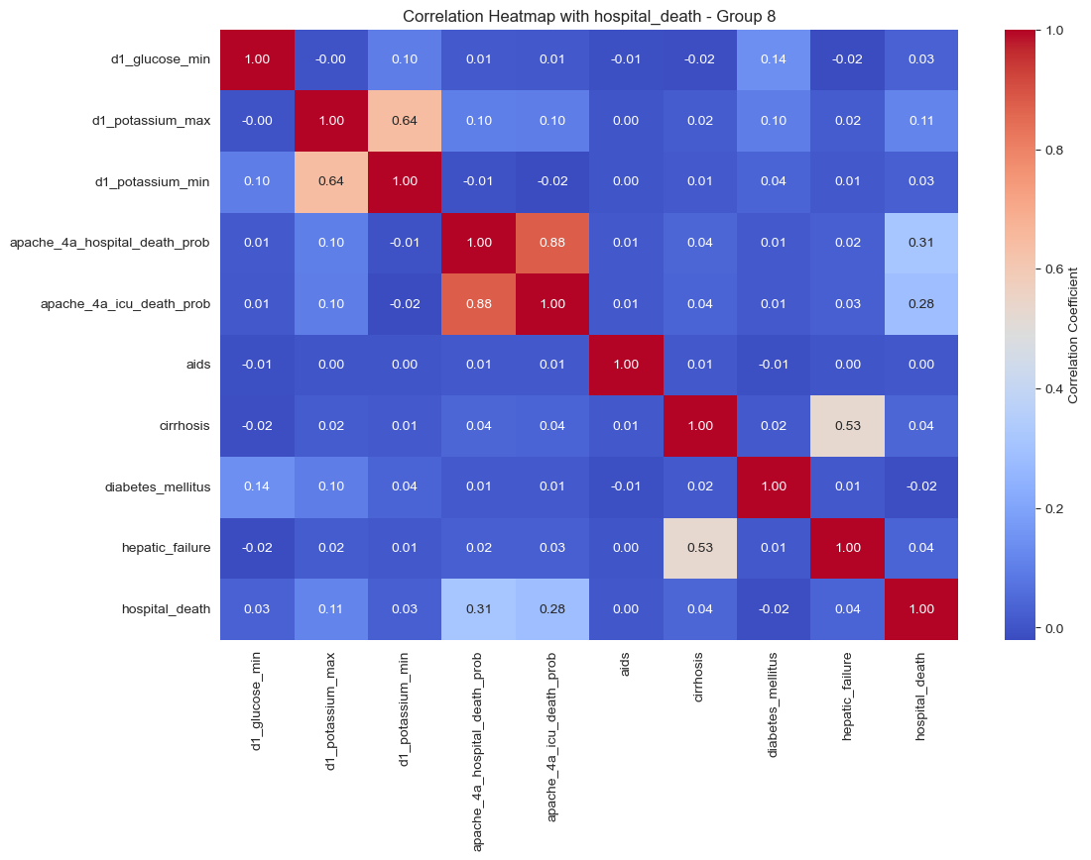
Correlation analyses were performed to identify the numerical characteristics most associated with the risk of in-hospital death in patients.By calculating the Pearson correlation coefficient between each numerical feature and the target variable hospital_death, the top 10 numerical features with the highest correlation with the target variable were filtered out.
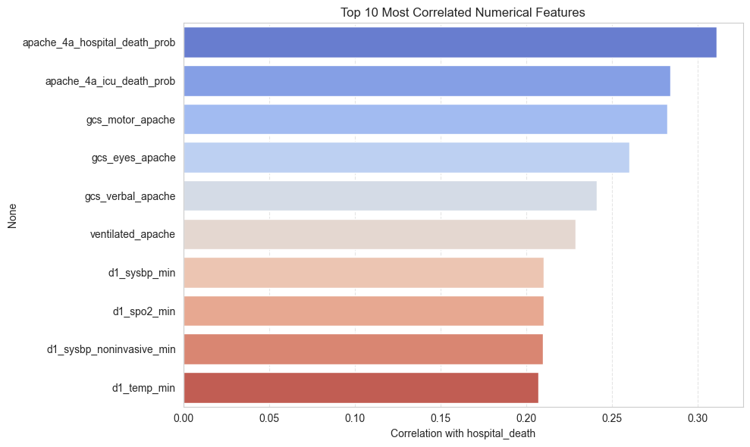
The results show that apache_4a_hospital_death_prob has the highest correlation with hospital_death at 0.311, indicating its strong predictive ability.Other features with high correlation include apache_4a_icu_death_prob, gcs_motor_apache, gcs_eyes_apache, and so on.These features are important in predicting the risk of death in patients.
Field Meaning
1. apache_4a_hospital_death_prob
o Meaning: Predicts the probability that a patient will die during a hospital stay based on the APACHE IV scoring system and other variables (value between 0 and 1).
2. apache_4a_icu_death_prob
o Meaning: predicts the probability (value between 0 and 1) that a patient will die while in the ICU based on the APACHE IV scoring system and other variables.
3. gcs_motor_apache
o Meaning: Glasgow Coma Scale "motor response" score (higher means more conscious).
4. gcs_eyes_apache
o Meaning: The Glasgow Coma Scale score for the "eye opening response".
5. gcs_verbal_apache
o Meaning: Glasgow Coma Scale "Verbal Response" score.
6. ventilated_apache
Meaning: Whether or not the patient received invasive mechanical ventilation within 24 hours of admission (1=yes, 0=no).
7. d1_sysbp_min
o Meaning: minimum systolic blood pressure (mmHg) within 24 hours of admission.
8. d1_spo2_min
o Meaning: minimum oxygen saturation (%) within 24 hours of admission.
9. d1_sysbp_noninvasive_min
o Meaning: lowest systolic blood pressure (mmHg) measured noninvasively within 24 hours of admission.
10.d1_temp_min
Meaning: lowest core body temperature (°C) within 24 hours of admission.
Impact analysis of hospital_death

Feature name | influence | analysis
apache_4a_hospital_death_prob | positive correlation | A high predicted probability of death is naturally more likely to occur hospital_death, with the highest correlation.
apache_4a_icu_death_prob | positive correlation | The higher the probability of death in the ICU, the higher the risk of death during hospitalisation.
gcs_motor_apache | negative correlation | The more conscious (high score), the lower the risk of death.
gcs_eyes_apache | negative correlation | Good eye opening response indicates better consciousness and low mortality.
gcs_verbal_apache | negative correlation | Being able to speak indicates better neurological function and low mortality.
ventilated_apache | positive correlation | The need for mechanical ventilation indicates a serious condition and a higher risk of death.
d1_sysbp_min | negative correlation | Low systolic blood pressure can lead to inadequate organ perfusion and increase the risk of death.
d1_spo2_min | negative correlation | A lower oxygen saturation indicates an inadequate oxygen supply and a poorer prognosis.
d1_sysbp_noninvasive_min | negative correlation | Consistent with d1_sysbp_min, representing circulatory instability.
d1_temp_min | negative correlation | Low body temperature (hypothermia) is one of the signs of serious illness and indicates a high risk of death.
Analysis of associations between categorical features and target variables
We assessed the association between each categorical feature and the target variable hospital_death using a chi-square test.By constructing a list of columns and calculating the chi-square statistic and p-value, it was determined whether each categorical feature was significantly associated with the target variable.All categorical features had p-values less than 0.05, indicating that they were significantly associated with the risk of patient death.Among them, apache_3j_bodysystem , icu_admit_source and apache_2_bodysystem are the two categorical features with the strongest association with the target variable.
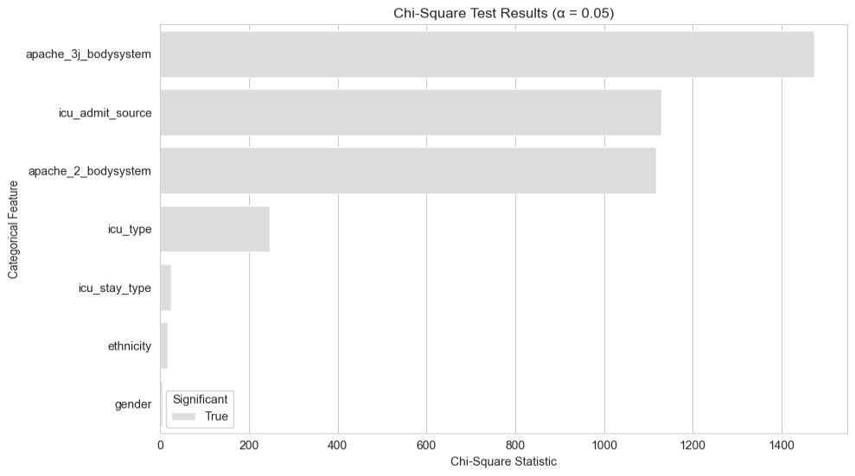
Explanation of field meanings
1.apache_3j_bodysystem
o Meaning: Classification of the main diagnostic system for admission based on the APACHE III model, e.g. "cardiovascular system", "neurological system", etc.
2. icu_admit_source
o Meaning: the source location of the patient before being admitted to the ICU, e.g., "emergency", "operating theatre", or "ward".
3. apache_2_bodysystem
o Meaning: APACHE II model-based classification of the system to which the admission diagnosis belongs, similar to apache_3j_bodysystem but with a slightly different basis for classification.
4. icu_type
o Meaning: ICU type, e.g. "MICU (Medical ICU)", "SICU (Surgical ICU)", etc., representing the speciality of the ICU.
5. icu_stay_type
Meaning: ICU admission type, such as "admit (first time to ICU)", "transfer (to ICU)", etc.
6. ethnicity
oMeaning: patient's ethnicity, such as "Caucasian", "African American", etc.
7. gender
Meaning: The patient's gender, including "M (male)", "F (female)" or "Other".
Impact analysis of hospital_death
The graph shows that the larger the chi-square statistic, the more significant the association of the variable with hospital_death (α = 0.05).
Feature name | significance | analysis
apache_3j_bodysystem | highly significant | The body system predominantly affected at the time of admission has a significant impact on morbidity and mortality, for example neurological disorders are highly correlated with mortality.
icu_admit_source | significant | Where one enters the ICU may represent the degree of urgency, e.g. those who enter from an emergency clinic are more likely to be in an emergency situation and have a higher mortality rate.
apache_2_bodysystem | significant | Similar to apache_3j, the primary diagnostic system significantly affects prognosis.
icu_type | significant | Different types of ICUs admit different categories of patients, reflecting the complexity of the condition.
icu_stay_type | Weaker  correlation | The mode of admission to the ICU (first admission or transfer) did not have as strong an effect on mortality as the previous ones.
ethnicity | weak correlation | Race is weakly correlated with mortality in this data.
gender | extremely weak correlation | The effect of gender on hospital_death is very limited and hardly statistically significant.

Distribution of the target variable
We also analysed the distribution of the target variable hospital_death.The distribution of the number of patients who died and survived during their hospitalisation is visualised by plotting a bar chart.The results show that the number of surviving patients is significantly higher than the number of dying patients, indicating some category imbalance in the dataset.
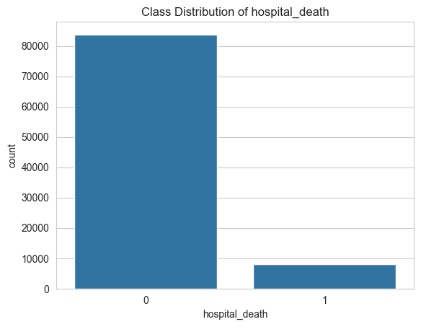

Modelling profiles and assessments
XGBoost:
XGBoost is an efficient decision tree integration algorithm based on the gradient boosting framework.It optimises computational efficiency and model performance by parallel computing and handling of missing values.It is widely used in classification and regression tasks for structured data.In this project, the dataset contains a large number of structured values and categorical variables, and XGBoost performs well on such data, while being robust and tolerant to missing values, and can handle missing automatically without additional interpolation.

Data Preprocessing
Data preprocessing is one of the key steps in the training process of XGBoost model.We processed the data as follows:
1. feature classification: features are classified into numerical (e.g., age, body mass index) and subtypes (e.g., race, gender).
2. missing value processing:
Numeric features: use median to fill in missing values.
Sub-typed features: use the string 'missing' to fill in missing values.
3. Feature selection:
Numerical features: use SelectKBest combined with analysis of variance (ANOVA F-value) to filter key features.
Sub-type features: use SelectKBest combined with chi-square test (chi2) to filter key features.
4. Feature coding:
Numerical features: the original features were retained as xgboost is not sensitive to standardisation of numerical variables.
Sub-typical features: uniquely hot encoding via OneHotEncoder, as 0-1 sparse matrices that can be used for model training.
handle_unknown='ignore' ensures no errors when unknown categories appear in the test set
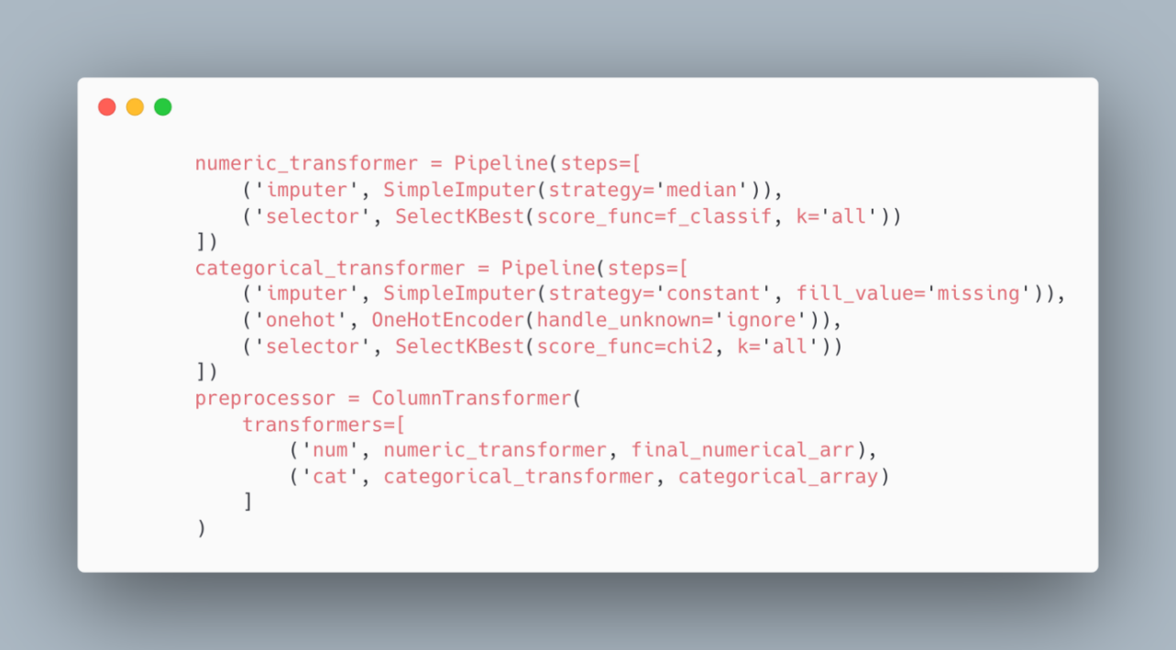
Model pipeline construction
We constructed a pipeline containing preprocessing and XGBoost classifiers:
Preprocessing step: numerical and categorical features are preprocessed separately using ColumnTransformer, including missing value filling, feature selection and encoding.
Modelling step: use XGBClassifier as the classifier, set the evaluation metric to 'logloss', the number of iterations to 100, the maximum depth to 5, and the random seed to 42.
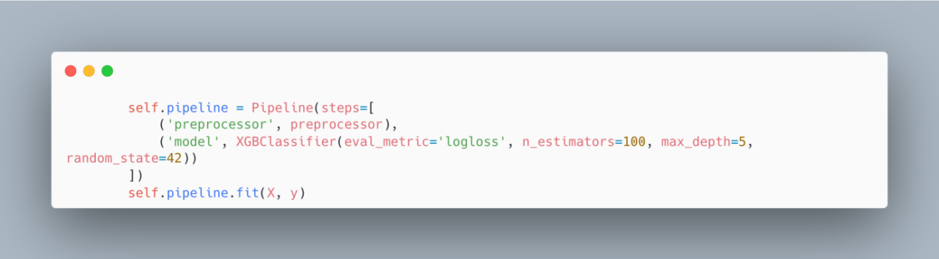
Model output results
The prediction results of the model on the test set are as follows:
Accuracy: 0.9228, indicating that the model correctly predicted about 92.28% of the samples.
Category Report:
Category 0 (survival):
Precision: 0.94, Recall: 0.98, F1 Score: 0.96, Number of Supported Samples: 16756.
Category 1 (death):
Precision: 0.61, Recall: 0.29, F1 Score: 0.39, Supporting Sample Size: 1587.
Overall Indicator:
Precision: 0.92, Macro average precision: 0.78, Recall: 0.64, F1 score: 0.68; Weighted average precision: 0.91, Recall: 0.92, F1 score: 0.91.
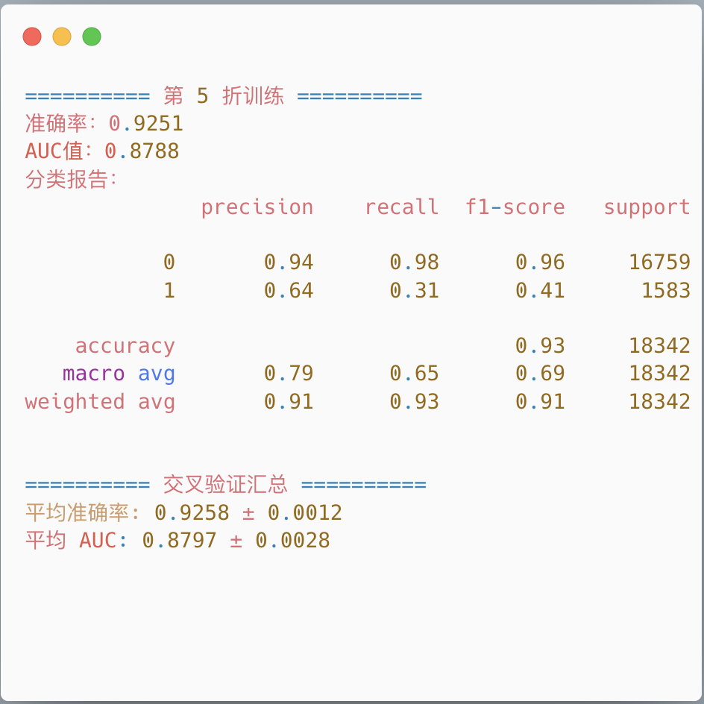
According to the results of the five-fold cross-validation of the XGBoost model, the model showed high overall performance in the task of inpatient death prediction.The average accuracy is 92.58%, indicating that the model is correct in judging the death of most patients; the AUC-ROC value is 0.8797, which indicates that the model has a strong differentiation ability and can effectively distinguish between dead and surviving patients.In terms of category prediction, the precision and recall of the non-dead category (category 0) were over 94%, and the model had very high recognition accuracy; however, it was more difficult to predict the dead category (category 1), with a recall of only about 31%, and an F1 score of 0.42, which indicated that the model had a high number of missed judgements.This is mainly affected by category imbalance.Overall, the model has strong prediction ability, and there is still room for optimisation in improving the recognition of a few death samples.

Model performance
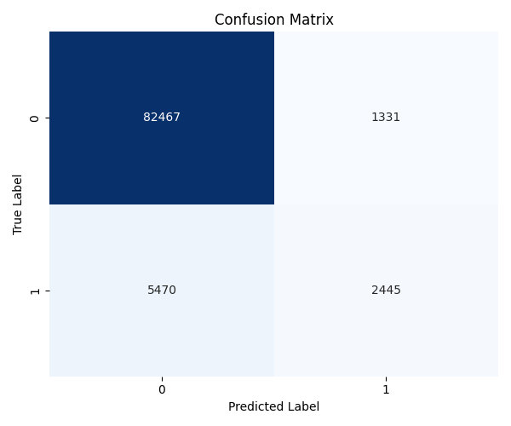
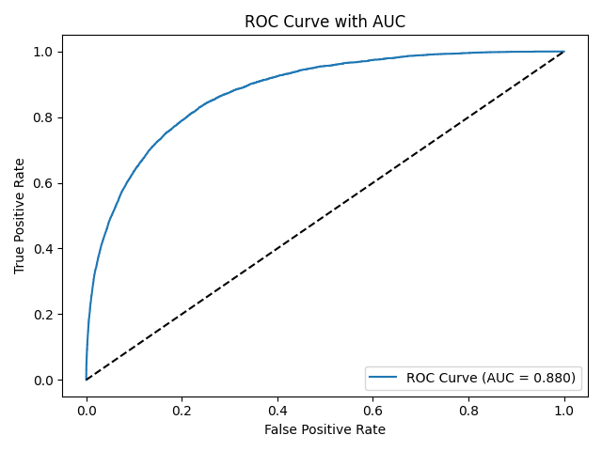
Based on the mean confusion matrix and ROC curve results, the XGBoost model performed well in predicting in-hospital deaths.In the confusion matrix, the model successfully predicted 82,467 patients who did not die and 2,445 patients who died, demonstrating high overall accuracy.However, 5,470 patients who actually died were still misclassified as not dead, suggesting that the model's ability to recognise a few categories needs to be strengthened.The area under the ROC curve (AUC) reached 0.880, suggesting that the model has strong overall discriminatory ability to effectively separate dead from not dead patients.Combining these indicators shows that the overall performance of the model is excellent, but there is still room for optimisation in reducing the omission of dead samples, and the recall and F1 score of the model can be subsequently improved by adjusting the threshold or dealing with category imbalance.

Logistic regression:
Logistic regression is a generalised linear model that uses logistic functions as link functions for binary classification problems.It predicts the probability of an event occurring by fitting a linear combination of logistic functions.In the EDA section in order to verify the correlation between the features and the target variable hospital_death, we performed Pearson's correlation coefficient analyses for all numerical variables and chi-square independence tests for categorical variables.The results showed that some of the variables were significantly associated with the risk of death, thus providing theoretical support for logistic regression modelling.

Data preprocessing and preprocessor construction process:
Feature classification:
Classification of features into numeric (e.g., age, body mass index) and subtypes (e.g., race, gender).
Feature Selection:
Numeric type: filter key features with SelectKBest combined with ANOVA (f_classif).
Subtypes: key features were screened with SelectKBest combined with chi-square test (chi2).
Missing value handling:
Numeric: fill missing values to median with SimpleImputer.
Subtype: populate missing values with SimpleImputer as the string 'missing'.
Feature Coding:
Numeric: normalised to remove the effect of magnitude.
Subtype: converted to numeric features with OneHotEncoder UniqueHotEncoder.
Preprocessor construction:
use ColumnTransformer to combine the pre-processing pipeline of numeric and sub-typed features to form a complete pre-processor for efficient processing of different types of data.
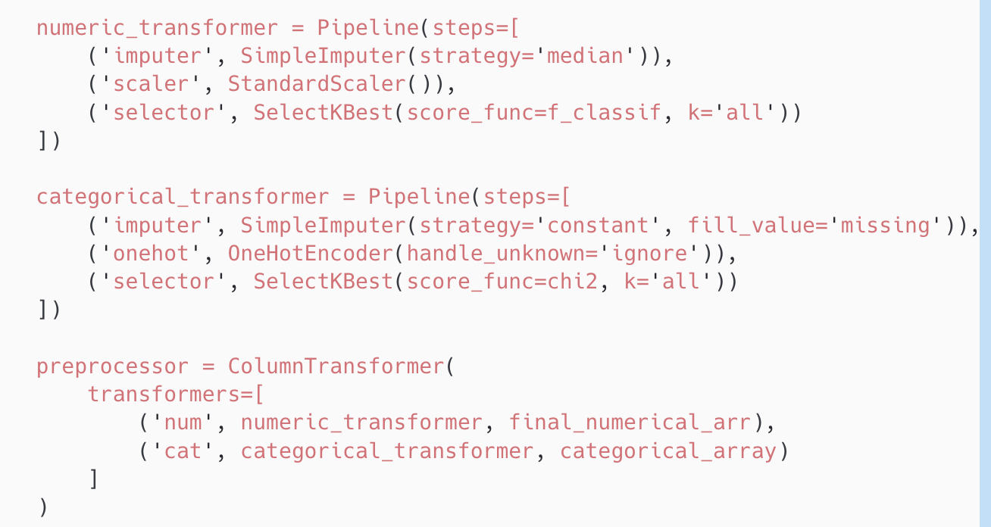
Model pipeline construction:
In the training of logistic regression models, we constructed a pipeline containing preprocessors and logistic regression classifiers for efficient model training and evaluation.The pipeline contains two main steps: a preprocessing step and a modelling step.The model step uses LogisticRegression as the classifier and sets the maximum number of iterations to 1000 (max_iter=1000).
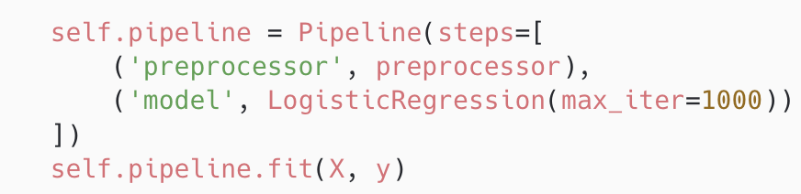
Model training results
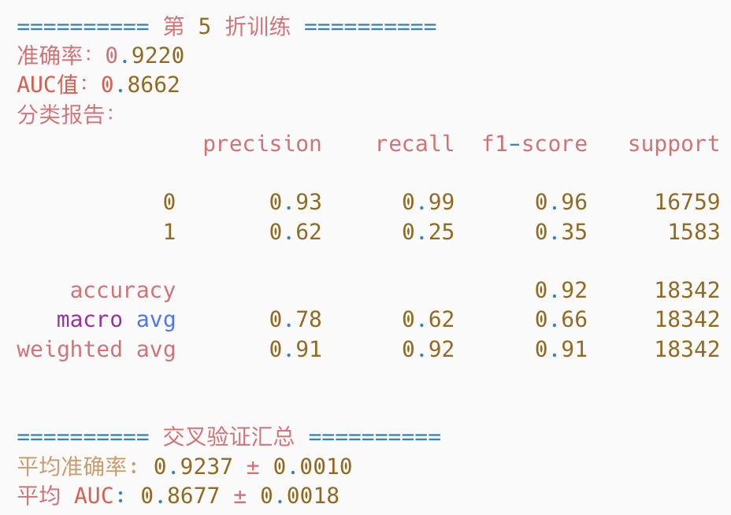
Model performance
The results of the five-fold cross-validation of the logistic regression model in the hospital death prediction task showed good overall performance.The average accuracy was 92.37%, indicating that the model was quite accurate for the overall sample; the average AUC was 0.8677, indicating that the model had strong discriminatory ability and was able to effectively differentiate between dead and non-dead patients.In terms of classification details, for non-dead patients (category 0), the model performs stably with a recall close to 99% and an F1 score as high as 0.96, indicating that the model is able to identify survivors almost completely.However, for truly dead patients (category 1), the model had a lower recall of only about 25%, i.e., most of the dead samples were misclassified as not dead; despite a precision of about 63%-67%, the F1 scores were only 0.35-0.37, reflecting the model's weaker ability to identify the dead category.This situation is mainly limited by the unbalanced distribution of the data, with the model preferring to predict the majority category.Overall, the logistic regression model is easy to interpret, stable in performance, and suitable for use as a baseline model, and there is still room for improvement in its ability to deal with the recall of the death category, which can be further optimised by combining resampling and threshold adjustment.

DNN Networks:
DNN (Deep Neural Network) is a feed-forward neural network with multiple hidden layers that automatically learns complex features and non-linear relationships in data.It adjusts the weights to minimise the prediction error through back propagation algorithm and activation function. In this project, the DNN is able to automatically extract features through a multi-layer network structure, discover "cross-features" or potential correlations, adapt to different types of inputs simultaneously (after normalisation), and have strong generalisation capabilities for problems with large sample sizes.
Data Preprocessing
Data preprocessing is one of the key steps in the training process of DNN models.We used the following methods to preprocess the data:
1. numerical feature processing:
Missing value padding: using the SimpleImputer strategy, the missing values of numerical features are padded with the median of the feature.
Normalisation: Normalisation of numeric features using StandardScaler.
2. Sub-type feature processing:
Missing value padding: use the SimpleImputer strategy to pad the missing value of the sub-typed feature as the string 'missing'.
Unique Hot Encoding: use OneHotEncoder to uniquely encode the sub-typed features and convert the categorical features to numeric features.
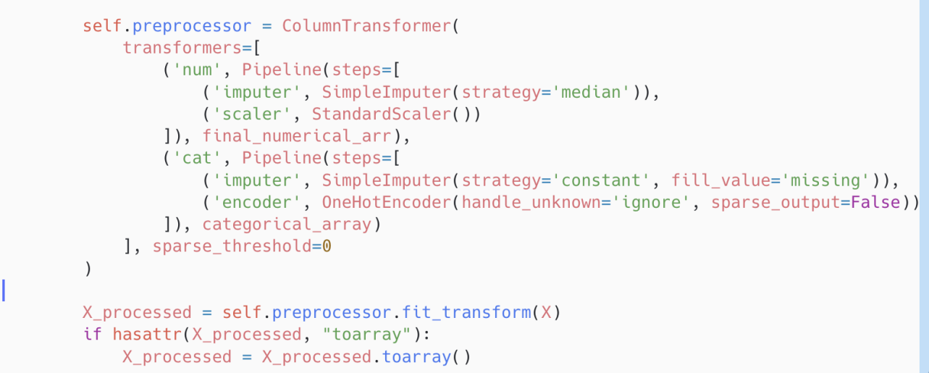
3. Uneven processing of data:
Use SMOTE (Synthetic Minority Class Oversampling Technique) to oversample minority classes (death labels) to balance the data set.
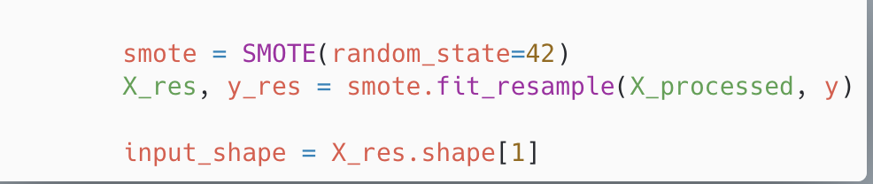
DNN network construction
We constructed a deep neural network (DNN) model with the following structure:
Input Layer:
The input dimension is dynamically determined based on the number of pre-processed features.
Hidden layer:
First layer: 256 neurons with ReLU activation function, followed by BatchNormalisation and Dropout (dropout rate 0.5).
Second layer: 128 neurons with ReLU activation function, followed by BatchNormalisation and Dropout (dropout rate 0.3).
Layer 3: 64 neurons, activation function is ReLU, followed by BatchNormalisation and Dropout (dropout rate 0.2).
Output layer: 1 neuron with Sigmoid activation function for binary classification task.
The model uses the Adam optimiser with a learning rate of 0.001 and a loss function of binary cross-entropy and monitors AUC metrics.EarlyStopping and ReduceLROnPlateau callback functions were used during training to prevent overfitting and improve the generalisation of the model.
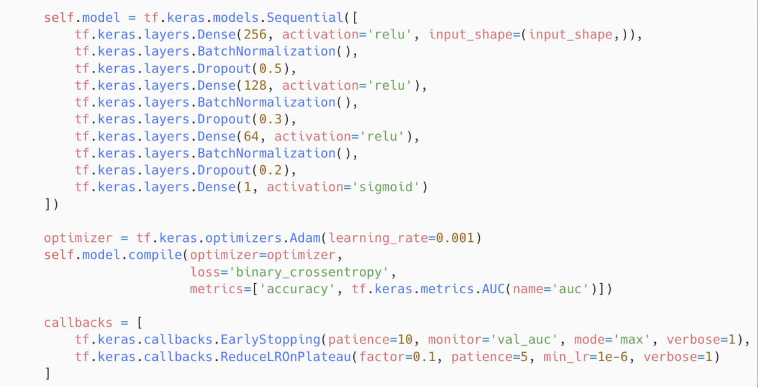
Validation method:
Training Validation Split: 20% of the data is used as the validation set during the training process to monitor the training and validation performance of the model in real time to prevent overfitting.
EarlyStopping mechanism: if the AUC value on the validation set does not improve within 10 consecutive epochs, training is stopped to avoid overfitting.
Learning rate adjustment (ReduceLROnPlateau): if the validation loss does not improve within 5 consecutive epochs, the learning rate is reduced to 1/10 of the original, with a minimum learning rate of 1e-6.
model output
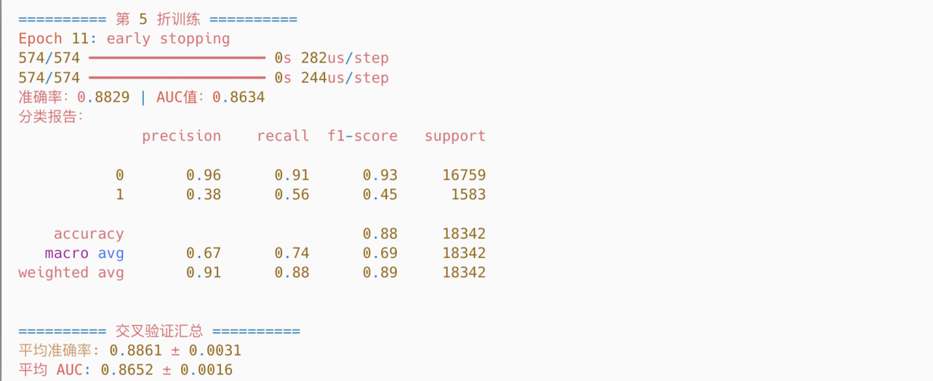
The DNN model performs stably in the hospital death prediction task, with an average accuracy of 88.61% and an AUC value of 0.8652, indicating that the model has a strong differentiation ability overall.In the classification report, it can be seen that for the non-death category (category 0), the model has good recognition ability, with a precision rate as high as 96%, a recall rate of about 91%, and a stable F1 score of 0.93-0.94; while for the death category (category 1), the model's recall rate improves to 55%-59%, which is superior to that of logistic regression and xgboost, with an F1 score of 0.45-0.47, which maintains precision while effectively reduces the rate of underdiagnosis.maintaining precision while effectively reducing the miss-recall rate.This result shows that the DNN model has some advantages in dealing with the category imbalance problem, mainly due to the incorporation of regularisation mechanisms such as SMOTE oversampling, BatchNormalization and Dropout, and the early stopping and learning rate adjustment strategies to improve the training stability and generalisation ability.Overall, the model achieves a better balance between accuracy and minority recall.

Model performance
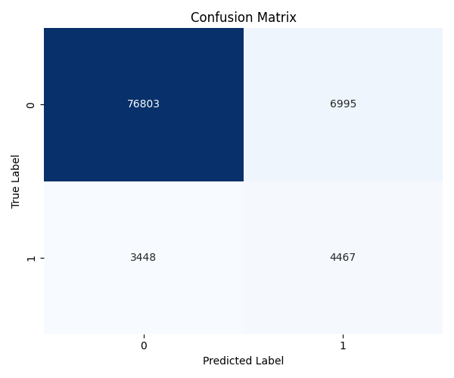
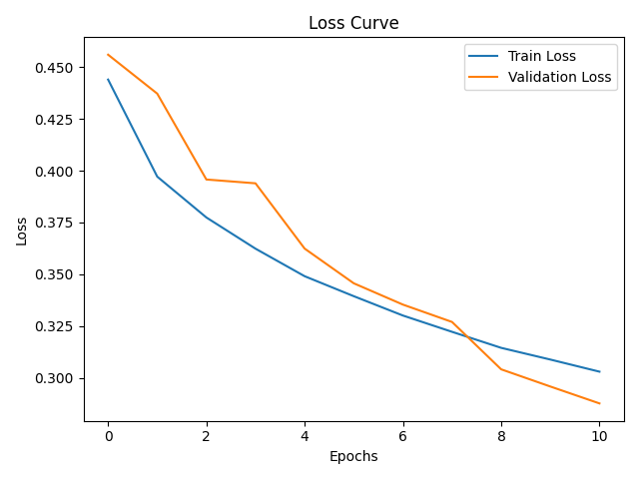
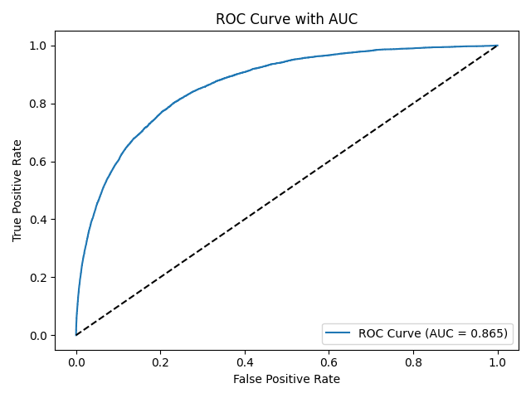
The average AUC value of the model in the five-fold cross-validation was 0.865, indicating that it has a good ability to discriminate between positive and negative samples (hospitalised dead or not).The ROC curves were stable and far from the diagonal, further validating the robustness of the model at different thresholds.
In terms of the final confusion matrix, the model successfully identified 4,467 patients who actually died, misclassified 3,448 dead patients as not dead, and also correctly identified the majority of non-dead patients (76,803).This indicates that the model improves recall for a few classes (deaths) while still maintaining a high overall accuracy.
The Loss curve shows that the training loss and validation loss decrease simultaneously without obvious signs of overfitting, and the final validation loss continues to decrease, indicating that the early stopping mechanism is successfully triggered near the optimal point, allowing the model to maintain good generalisation performance during training.
In summary, the DNN model performs robustly in the death prediction task, taking into account the accuracy and the recall ability of dead cases.

Model Stacking
Model stacking is an integrated learning technique that further improves the overall prediction accuracy and generalisation by combining the prediction results from multiple base models.The core idea is to use a meta-model to integrate the outputs of base models to generate the final prediction results.This approach can give full play to the advantages of each base model and make up for the deficiencies of a single model, which is especially suitable for dealing with complex prediction tasks.
In this project, we adopt the model stacking technique to combine the prediction results of the base models (XGBoost, DNN, Logistic Regression), and use the prediction results of the base models as new feature inputs to train a new model (Logistic Regression) for final prediction.
Model Construction
The stacked model consists of three base models and one meta-model:
1. base model:
DNN model: contains a multi-layer neural network, capable of handling complex non-linear relationships.
Logistic regression model: a linear model, used to deal with binary classification problems.
XGBoost model: decision tree algorithm based on gradient boosting, suitable for structured data.
2. Meta-model: uses logistic regression as a meta-model to integrate the prediction results of the base model for final prediction.
Cross-Validation (Cross-Validation)
In order to comprehensively evaluate the performance of stacked models and avoid overfitting, we designed a two-layer cross-validation structure and introduced the OOF (Out-of-Fold) feature generation mechanism.The overall process is as follows:
Outer layer cross-validation (StratifiedKFold)
In the outermost layer, we use StratifiedKFold (hierarchical K-fold cross-validation) to divide the original data into training and validation sets.This method ensures that the category distribution of the target variable (hospital_death) in each fold is consistent with the whole, effectively mitigating the risk of bias caused by category imbalance.The implementation is as follows:
skf = StratifiedKFold(n_splits=n_splits, shuffle=True, random_state=42)
for train_index, val_index in skf.split(X, y):
...
In each fold loop, 4 folds of data are used to train the base model and meta-model, and the remaining 1 fold is used to evaluate the performance of the current stacked model.
Inner OOF feature generation (KFold)
For each base model (XGBoost, DNN, logistic regression), we perform another KFold (non-hierarchical) cross-training inside the training set, which is used to generate the OOF (Out-of-Fold) prediction probability of that model.This strategy avoids leaking target label information to the meta-model, while ensuring that each sample in the training data has a corresponding base model prediction.The code is implemented as follows:
kf = KFold(n_splits=5, shuffle=True, random_state=42)
for train_idx, valid_idx in kf.split(X):
...
The use of StratifiedKFold instead of KFold as the outer layer validation method is to keep the proportion of positive and negative samples in each fold consistent in the unbalanced binary classification task, making the evaluation results more realistic and robust.The reason for using KFold when obtaining OOF features internally is that OOF is only used to generate pseudo-labelling probabilities and will not be involved in the final validation evaluation, so no additional layering is needed to avoid the increase in computational complexity.

Multiple Base Model Training (Base Models)
In each fold, we train the following three base models separately:
•XGBoostModel: excellent performance on structured data, strong ability to handle non-linear relationships;
•DNNModel: deep learning capability, abstract feature representation;
•LogisticModel: linear model with strong stability and high computational efficiency.
The training code is shown below:
base_models = []
for model_class in [DNNModel, LogisticModel, XGBoostModel]:
model = model_class()
model.fit(X_train, y_train)
base_models.append(model)
Base model outputs converted to metamodel inputs (OOF features)
In the stacked model, the inputs to the metamodel are not the original features, but the predictions of each base model for the samples.In order to make these predictions representative without revealing label information, we adopt the KFold cross-prediction (Out-of-Fold) approach to generate meta-features in the training phase.
For each base model (e.g., DNN, XGBoost, logistic regression):
1. Divide the training set X_train into 5 folds;
2. For each fold: train the base model with the remaining 4 folds of data and make a prediction on the current 1 fold;
3. Predictions for all folds are stitched together to get the OOF prediction probability of the model for all training samples;
4. At the same time, use the base model to predict on the validation set X_val, and get the validation set prediction probability of the model.
for model in base_models:
oof_train, oof_val = get_oof_predictions(model, X_train, y_train, X_val, n_splits=5)
meta_train_features.append(oof_train)
meta_val_features.append(oof_val)
X_meta_train = np.hstack(meta_train_features)
(X_meta_train = np.hstack([oof_1, oof_2, oof_3]) # shape: (n_samples, 3))
X_meta_val = np.hstack(meta_val_features)
The key to this step is to provide the meta-model (logistic regression) with a "confidence distribution" of the samples from different models, allowing it to learn a more comprehensive basis for predictive decisions.
Why use OOF features instead of direct prediction?
• Predicting results directly from the training set can lead to leakage of label information and the metamodel may "cheat", resulting in overfitting;
• Using OOF features ensures that the predictions for each training sample are "never before seen by the model", thus allowing the meta-model to learn more robustly;
• validation set uses features spliced together from the predicted probabilities of multiple base models, providing model diversity and a richer input space for the meta-model.
Meta Model Training and Prediction (Meta Model)
We chose logistic regression as the final meta model to fuse the predictions of multiple base models:
meta_model = LogisticRegression()
meta_model.fit(X_meta_train, y_train)
y_val_pred = meta_model.predict(X_meta_val)
y_val_prob = meta_model.predict_proba(X_meta_val)[:, 1]
Model Evaluation and Optimal Model Saving
In each fold, accuracy, AUC and classification reports are recorded and the stacked model corresponding to the best AUC fold is saved :
if auc > best_auc:
best_auc = auc
best_models = base_models
best_meta_model = meta_model
with open(MODEL_DIR / "base_models.pkl", "wb") as f:
cloudpickle.dump(best_models, f)
with open(MODEL_DIR / "meta_model.pkl", "wb") as f:
cloudpickle.dump(best_meta_model, f)
Why save the best AUC model?
•AUC (Area Under ROC Curve) measures the model's ability to distinguish between positive and negative samples (dead and undead);
• It is insensitive to category imbalance and is well suited to the task of death prediction (few categories);
• In contrast to accuracy, AUC does not mask model performance by having the majority class overwhelm the minority class.
The purpose of preserving the optimal model for AUC is to select the most discriminatory solution among multiple model combinations to ensure that the model ultimately used has the most robust predictive performance, especially for highly sensitive imbalance problems such as death prediction

Model training results
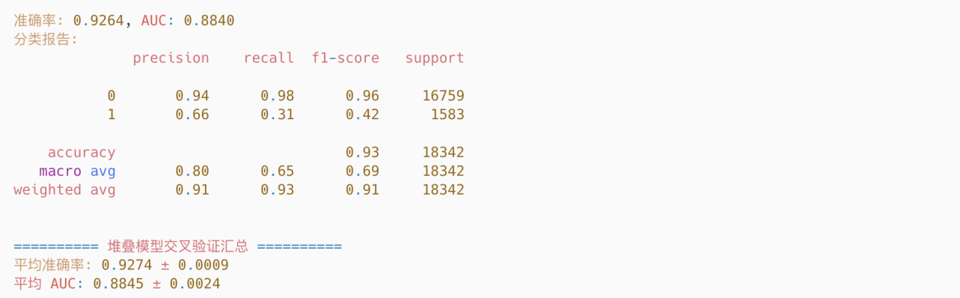
The stacked model shows excellent and stable performance in the hospital death prediction task.The overall average accuracy is 92.74%, and the average AUC value is 0.8845, indicating that the model has strong sample differentiation ability, which is especially suitable for dealing with the current medical data scenario with unbalanced categories.Among the folds, the recall of death samples (category 1) is stable at about 31%, with F1 scores ranging from 0.42 to 0.43, which is significantly better than the performance of a single model, showing that the stacked integration improves the ability of identifying high-risk patients; and the prediction accuracy of survival samples (category 0) maintains about 98%, with an F1 score of close to 0.96, which maintains a high degree of stability.By integrating the prediction results of the three base models of DNN, XGBoost and logistic regression, and then using logistic regression as the meta-model fusion, the model makes full use of the advantages of different models, and improves the ability of identifying a few categories while maintaining a high overall accuracy.In the end, we selected the one fold with the highest AUC value (0.8883) to save the corresponding model.

modelling assessment
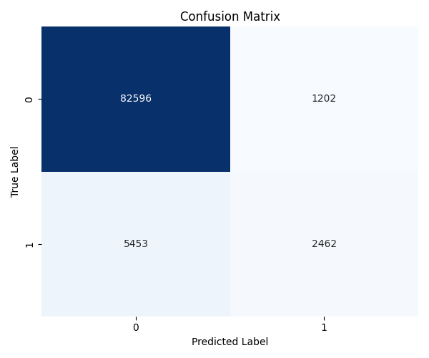
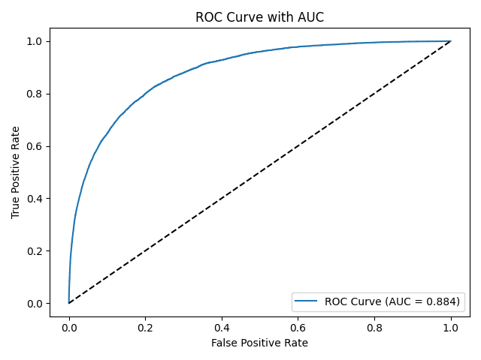
The confusion matrix shows that the model successfully identified the majority of surviving patients (TN = 82,596) and a proportion of dying patients (TP = 2,462) in the test set, with 5,453 misclassifications of death as survival (FN) and 1,202 misclassifications of survival as death (FP).This suggests that the model has a high ability to recognise the majority category (survival) and maintains some ability to recognise the minority category (death) when faced with it, but there is still some risk of under-recognition. The AUC value under the ROC curve is 0.884, indicating that the model has a strong ability to distinguish between life and death categories as a whole.

Integrating the strengths of each model
The Stacking approach used in this project fully integrates three types of base models with complementary strengths: DNN, XGBoost and logistic regression.The method builds a two-tier model structure, using multiple base models to predict the samples in the first tier, and logistic regression as a meta-model in the second tier to re-learn the prediction probabilities of the base models, so as to form a more accurate and stable final prediction result.Its advantages are reflected in the following aspects:
1. Strong model complementarity to improve overall performance
•XGBoost performs stably in structured data, has strong feature selection ability and overfitting resistance, and can capture regular features well;
•DNN Through the combination of multi-layer non-linear neurons, it is good at mining non-linear relationships from high-dimensional complex data, and can identify potential higher-order interaction features;
• logistic regression Simple in structure and interpretable, it can capture linear relationships stably and has good generalisation ability when features are sparse or data size is large.
By combining these three types of models, stacked models can effectively synthesise their strengths in different aspects, thus making up for the deficiencies of a single model.
2. Prevent overfitting and enhance generalisation ability
During model training, we construct OOF (Out-of-Fold) prediction features for each base model, i.e., we use "unseen" model folds for each sample in the training set to avoid target information leakage.At the same time, the meta-model is trained only on these OOF results, which makes the final model fusion more robust. 3.
3. Learning the "prediction confidence" of different models and intelligently weighting the judgements
The death probability output from each base model is spliced into new 3D feature inputs, and the metamodel logistic regression learns the prediction tendency of each base model in different scenarios, and thus automatically assigns weights.For example, when both XGBoost and DNN judge the probability of death to be high, the metamodel is more likely to judge it to be dead; conversely, if only the logistic regression is biased to be high, the metamodel may be more conservative.
4. Experimental results verify that the fusion effect is significant
From the final experimental results, the stacked model performs stably in the five-fold cross-validation, with an average accuracy of 92.74% and an AUC value of 0.8845, which is better than the results of the individual training of each base model, suggesting that it has a better ability to identify deaths and generalisation in sample imbalance scenarios.

User Interface Guidelines and Implementation Details
Introduction of the system
The application is a clinical mortality risk assessment tool based on stacked integrated learning models that supports both single case manual entry and batch case CSV upload modes.The system predicts the probability of death risk in hospitalised patients by combining the APACHE scoring system with physiological indicators.
Interface Components
Input Module:
Single case mode:
5 core numerical type feature inputs (with clinical significance descriptions)
Drop-down selection of 7 key categorical features
[Important design] 72 other auxiliary fields auto-populated with default values (numeric type 0, classification set to missing)
Batch mode:
Support CSV file upload, automatic processing of UTF-8/GBK encoding
77 fields integrity check
[Technical features] file reading using Pandas, support for memory caching
Output Module:
Single-case prediction: binary classification results (death/survival) + death probability value (4-bit precision)
Batch processing: complete results table display, support web page directly export prediction CSV
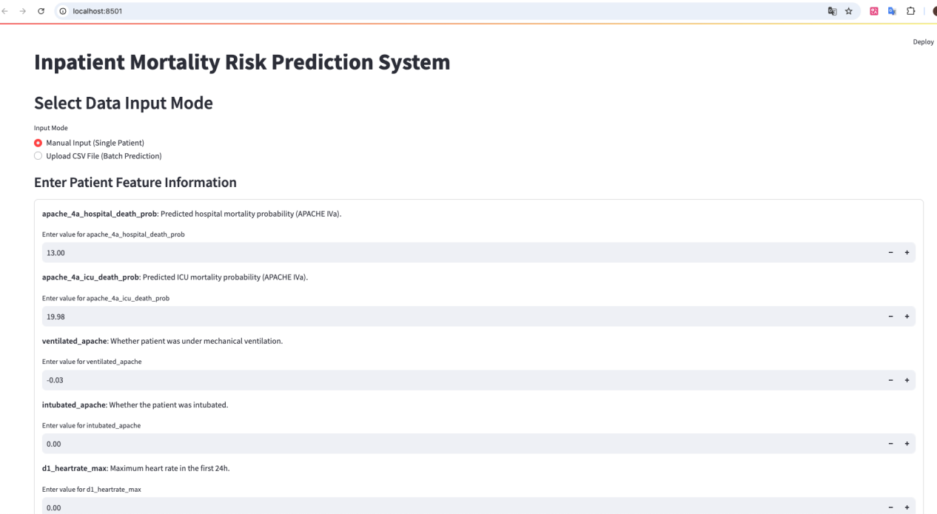

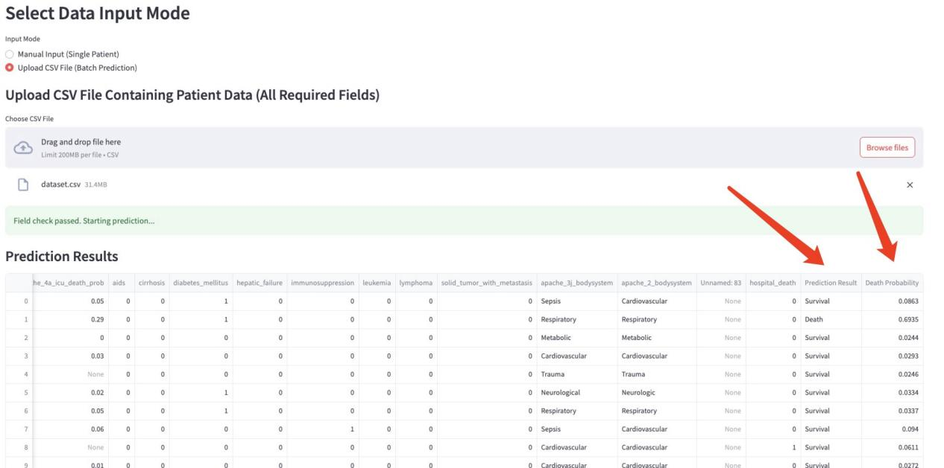


Environment Deployment
Important prerequisites

Python 3.7+
scikit-learn==1.0.2
pandas>=1.3.0
streamlit>=1.11.0
cloudpickle>=2.0.0

Deployment Process

# 1. Clone the repository
git clone https://github.com/Delysid749/Patient-Survival-Prediction.git
cd project_dir

# 2. Run the application (default port 8501)
streamlit run app/main.py

# 3. Browser access
localhost:8501
Operation Guide
Single Case Mode
Data entry logic:
The system forces the completion of 5 numeric + 7 classification fields entry
Field descriptions use dynamic rendering technology to display medical definitions in real time.
Core constraints: Numeric fields must be floating point numbers, and classification fields are limited to predefined options.
Validation process:
[Post Validation Logic] 72 auxiliary field defaults are automatically populated upon submission
Data is assembled into a DataFrame and sent directly to the model.
Result Interpretation:
Green indicates survival prediction, red highlights death prediction, probability value retains 4 decimal places.

Batch model
File preparation specification:
Column names must contain the required 77 feature field names
Other columns are allowed but will be automatically ignored
[Encoding compatibility] UTF-8 BOM-free format is recommended as a priority
Checksum mechanism:
Feature Integrity Check: Immediate reporting of missing field lists
Data type auto conversion:
Category columns are automatically converted to category type
Numeric columns are forced to convert to float format
Output Management:
Default display of first 100 rows for in-browser results display
Support to export the complete prediction results CSV (including the original data + two new columns)

III. System work flow summary
1. Initialization & Model Loading
Set the project root directory for relative imports.
Load two model files:
base_models.pkl: base-level models (e.g., XGBoost, DNN, etc.)
meta_model.pkl: meta-level model for stacking ensemble.
2. Feature Configuration
Define two field groups:
TOP_N_NUMERIC_FIELDS: important numeric variables such as APACHE scores, intubation status.
TOP_CATEGORICAL_FIELDS: key categorical features like ICU type, admission source, gender.
Use field_description to explain each field in English.
Use category_options to populate select boxes for categorical fields.
3. Input Mode Selection
Provide two modes:
Manual input for a single patient
Batch prediction via uploaded CSV file
4. Manual Patient Input
Render a clean input form with st.form() for better layout.
Use st.number_input for numeric fields, showing field descriptions.
Use st.selectbox for categorical variables, with dropdown options and labels.
On submission, call predict_new_patients() to compute prediction and probability, then display result.
5. Batch Prediction via CSV Upload
Accept user-uploaded CSV files, supporting both UTF-8 and GBK encoding.
Check whether required columns are included; show errors if missing.
Once verified, run prediction for each patient using predict_new_patients().
Show results in a table and allow the user to download predictions as CSV.

Summary
This project successfully developed a machine learning model capable of accurately predicting the risk of patient death during hospitalisation using the Patient Survival Prediction dataset with four base models, LightGBM, XGBoost, logistic regression and DNN, as well as stacked models.We compared the outputs of these models and found that LightGBM and XGBoost performed the best in terms of prediction accuracy, sensitivity and specificity, meeting the performance goals set by the project.Through this project, we have not only successfully constructed highly accurate prediction models, but also developed user-friendly interfaces that can be easily applied by healthcare professionals in practice, thereby improving the quality of healthcare services and the science of clinical decision-making.

